# EuroSkills Herning 2025 - EuroSkills 2025

# **IT Network Systems Administration**

## **National Final**

## 24th-25th April 2024

## Budapest, Hungary

# **Day 2**

# God eftermiddag!

# First of all, congratulations for helping us configure our servers at our headquarters. We were so impressed once again that we want your help once again, although at a bigger scale than before.

# As you may be aware, Lego is not a small company. In fact, we have several sites which all host several servers. We need your expertise in configuring them.

# Some of the servers at the HQ are pre-configured, but they are not finished. Also, you need to configure one of our new sites.

# Remember to test every change you make, create snapshots before making changes and save all your work.

# **Preliminary Notice**

1. **X always means your desk number.**
2. All **devices will be rebooted** before marking. Ensure that all your settings are kept during reboots.
3. **Only running services will be marked.**
4. Use the password ***Euro2025+*** everywhere, where you need to configure password, passphrase or anything like that.





## Accessing infrastructure

You will access servers and clients from VMware Workstation at *vmware.euroskills* URL. Your credentials will be given separately.

## Sites and machines

### Headquarters

* HQ-AD: Windows Server, IPv4 address: 172.16.0.1/25
* HQ-FILE: Windows Server, IPv4 address: 172.16.0.3/25
* HQ-WEB1: Debian, IPv4 address: 172.16.0.11/25
* HQ-WEB2: Debian, IPv4 address: 172.16.0.12/25
* HQ-LINK: Debian, IPv4 address: 172.16.0.126/25, WAN: 100.100.100.1/30
* HQ-MGMT: Debian, IPv4 address: DHCP

### Billund

* HOUSE-AD: Windows Server (Core), IPv4 address: 10.0.0.1/24
* HOUSE-MAIL: Debian, IPv4 address: 10.0.0.2/24
* HOUSE-LINK: Debian, IPv4 address: 10.0.0.254/24, WAN: 100.100.100.2/30
* HOUSE-CLIENT: Windows 10, IPv4 address: DHCP

## Active Directory basic settings

**Domain:** lego.local

#### Users

|  |  |  |
| --- | --- | --- |
| Username | Full Name | Group |
| anders.isaksen | Anders Isaksen | Site Admin |
| emil.klausen | Emil Klausen | Accountant |
| cecilie.therkildsen | Cecilie Therkildsen | Accountant |
| astrid.due | Astrid Due | Production |

## Pre-Configured services

On HQ-WEB1 and HQ-WEB2 we have already installed Apache2 and we already host a website on it. The website’s content is the server’s name.

On both clients you will have an internet browser and a mail client.

## System Topology

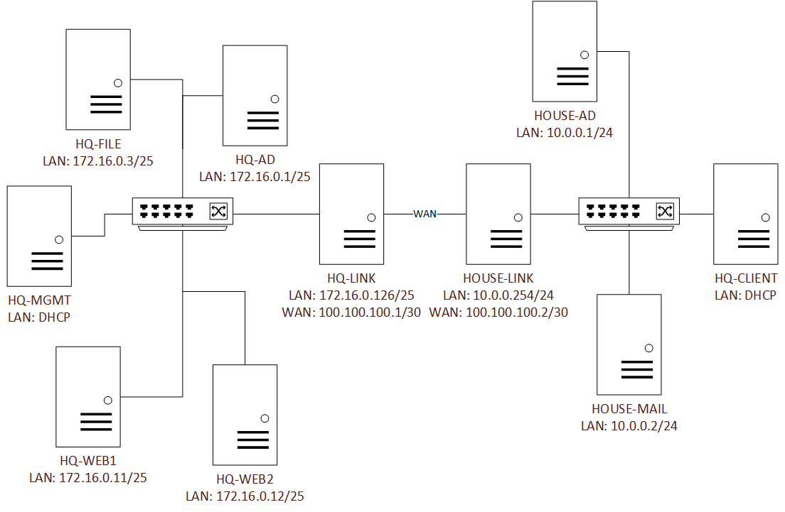

# Preliminary Tasks

* Ensure that every computer is in the domain.
* Every known host should have ICMP reachability to each other.

# Tasks

1. Create the necessary objects in AD. Consider the following:
   1. For every OU there should be a security group.
   2. Members of “Site Admin” should be members of Domain Administrators.
   3. Create users Worker1 to Worker100. They all should be members of Production.
2. Create GPOs:
   1. No first sign-in animation should be displayed.
   2. “Site Admin” members should have local administrator permissions on every domain-joined machine.
   3. The default password policy should be that the password cannot be the same as the previous 8 passwords and every users should change the password every 90 days.
3. On the HQ-AD, create a DHCP pool with these settings:
   1. Range is between .51 and .100.
   2. Give necessary information to clients.
   3. .75 should go to HQ-MGMT.
4. Create and configure necessary directories on the HQ-FILE:
   1. C:\Company_Data
      1. IT – Only “Site Admin” should have access to it.
      2. Schematics – “Production” should have Read privileges, “Site Admin” should have Full Control access.
      3. Finance – “Accountant” should have Modify privileges, “Site Admin” should have Full Control access.
      4. Learning – “Site Admin" should have Full Control access, everyone in the domain should have Read privileges
   2. Configuration:
      1. IT – only .txt, .ps1, .bat and .docx extensions are allowed.
      2. Schematics – only PDF-s are allowed. It’s maximum size is 500MB. Warning should come at 250MB and 400MB.
      3. Finance – only .xls and .xlsx files are allowed.
      4. Log every alert.
   3. Reports
      1. Schedule a report about Company_Data.
      2. The “Site Admin” should receive the report every day at 12:00
5. Configure RRAS on HQ-AD:
   1. Clients should get their address via DHCP.
   2. Only “Site Admin” and “Accountant” members should be able to log in.
6. Configure HAproxy on HQ-LINK so it load-balances our two webservers. Also, if using port 8000 then HQ-WEB1 should be accessed and if using port 8001 then HQ-WEB2 should be accessed.
7. On every LINK server configure frr:
   1. Both sites should know the other via BGP.
   2. AS number should be 65125
8. On HOUSE-AD, configure the following:
   1. It should be a domain controller.
   2. There needs to be a DHCP pool:
      1. Range is .100-.199
      2. Give necessary information to clients.
      3. HOUSE-CLIENT should get .166.
9. Configure mail services on HOUSE-MAIL. Every named user should have a mailbox.
   1. From HOUSE-CLIENT, send a mail from Astrid to Anders.
   2. From HQ-MGMT, send a mail from Anders to Emil.
10. Create scripts on HOUSE-AD:
    1. We need a script that lists every AD user. In the export we need the Full Name, Username and Group Memberships.
    2. We need a script that tries to reach every server via ICMP and then gives an output: “Successful pings: X, Failed pings: Y, Network health: Z%” (X is the number of successful pings, Y is the number of failed pings, Z = Successful pings/All pings)
    3. We need a script that outputs every disabled accounts into a file. The filename is: “locked_{date}_{hour}_{minute}.txt

## Functional tests

1. By accessing [www.lego.local](http://www.lego.local) you should see different outputs every time you reload the site.
2. Connect the HOUSE-CLIENT to the HQ site via VPN.